Miles A. Peña

DSC 520 Statistics for Data Science

Chase Denton

December 2, 2023

Week 1 - Discovering Statistics Using R Tasks

**Task 4:**

Say I own 857 CDs. My friend has written a computer program that uses a webcam to scan the shelves in my house where I keep my CDs and measure how many I have. His program says that I have 863 CDs. Define measurement error. What is the measurement error in my friend’s CD-counting device?

Measurement error is the difference between the observed value of a variable and the actual value of said variable. In this case, the measurement error is 6.

**Task 5:**

Sketch the shape of a normal distribution, a positively skewed distribution, and a negatively skewed distribution.

Normal Distribution:

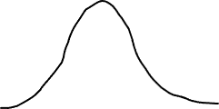

Positively Skewed Distribution:

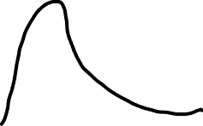

Negatively Skewed Distribution:

